**Computer Engineering Case Study – Image Features Extraction using Gray Level Cooccurrence Matrix (GLCM)**

**Yousef Al-Jazzazi**

***ENGR-AD 1000, Fall 2022***

**STEP 1: Problem Identification and Statement**

The problem is extracting the features, such as contrast, energy, and homogeneity, from a file containing image data/pixel information.

**STEP 2: Gathering of Information and Input and Output Description**

Gray Level Co-occurrence Matrix (GLCM) represents the spatial relationships of pixels in the image. GLCM examines the spatial relationship among pixels and defines how frequently a combination of pixels is present in an image in a given direction **θ** and distance **d**. Using GLCM, you can derive several statistics like ‘contrast,’ ‘energy,’ and ‘homogeneity.’ These statistics provide information about the texture of an image.

Creating GLCM from image pixel information:

Before creating GLCM, we should find the maximum gray level in the image- as the dimensions of the GLCM depend on the maximum gray level in an image. The dimensions of GLCM should be set as the maximum value plus one.

For the values inside GLCM, the figure below illustrates the process used to create the GLCM from an image with 8 gray levels.

In the output GLCM, element (1,1) contains the value 1 because there is only one instance in the input image where two horizontally adjacent pixels have the values 1 and 1, respectively. Element (1,2) contains the value 2 because there are two instances where two horizontally adjacent pixels have values 1 and 2. Element (1,3) in the GLCM has the value 0 because there are no instances of two horizontally adjacent pixels with the values 1 and 3.

Creating normalized GLCM from the GLCM matrix:

A normalized GLCM matrix has the same dimension as the GLCM matrix. The values inside the GLCM matrix at a given point (i,j) is equal to the value of the point in GLCM that has the same location divided by the sum of values in GLCM. Look equation below:

Finding the values of the attributes of an image (contrast, energy, homogeneity) using normalized GLCM matrix: a

The attributes can be calculated using these equations where p(i,j) is the value in the Normalized GLCM matrix at location (i,j):

Dealing with Files:

The image data information is going to be passed by file. The data in the file is assumed to have the dimensions of the image stored in the first line as (columns, rows), followed by the pixel information. Look example below:

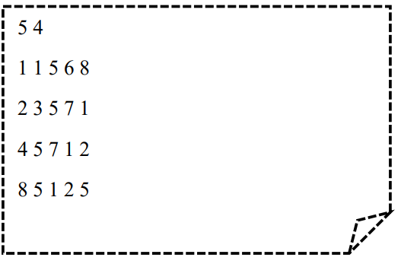

Furthermore, it is assumed that the file contains at least information of size 2X2 and that all the values inside are positive integers.

Note: The file will be given by the user. Our algorithm is concerned with running the calculation from the information in the file not producing it.

This will be organized through a menu where it is going to ask the user what function of the program they want to work with, namely (1) Create and normalize the GLCM matrix (2) Compute the statistical parameters of the texture – we assume for this function that the user wants to see the results as well, so they are printed when the user calls this function(3) Print the GLCM matrix- the normalized matrix will not be printed(4) quit the program. It is important to mention that the program will ask the user for a file name even before the user gets to the menu, and unless the user gives a valid file name, they will not be able to access the menu. They can choose to exit the program by typing 0.

In case the user selects the first option from the menu (Create and normalize the GLCM matrix), the program is going to create the GLCM matrix and create another identical matrix that will be normalized. The program then returns to the main menu. If the user selects the second option and they did not create the GLCM matrix, the program will print a message stating that they should create the matrix first. If they choose the second option and the matrix has been created, the program is going to calculate the attributes (energy, homogeneity, and contrast) of the image using the normalized GLCM and print these attributes. The program then returns to the main menu. If the user selects the third option and they did not create the GLCM matrix, the program will print a message stating that they should create the matrix first. If they choose the third option and the matrix has been created, the program will print the GLCM matrix. If the user selects the exit option, the program prints a terminating message and quits the program.

**I/O description:**

The program will take three inputs and produce one output:

**GLCM matrix**

**Name of file**

**The values of the contrast, energy, homogeneity attributes**

**STEP3: Test Cases and Algorithm Design:**

1. Test cases

The values of the attributes were calculated using website [mathworks](https://www.mathworks.com/help/images/ref/graycoprops.html).

Test case #1:

File: “image.txt”

5 4

1 1 5 6 8

2 3 5 7 1

4 5 7 1 2

8 5 1 2 5

|  |  |  |  |  |  |
| --- | --- | --- | --- | --- | --- |
| **File Name Input [String]** | **Menu input [String]** | **Output** | **Menu input [String]** | **Output** | **Menu Input [String]** |
| image.txt | 1 | Done | 2 | Contrast: 8.93  Energy: 0.086  Homogeneity: 0.3762 | 3 |

**Continue**

|  |  |  |
| --- | --- | --- |
| **Output** | **Go back to menu** | **Output** |
| 0 0 0 0 0 0 0 0 0  0 1 2 0 0 1 0 0 0  0 0 0 1 0 1 0 0 0  0 0 0 0 0 1 0 0 0  0 0 0 0 0 1 0 0 0  0 1 0 0 0 0 1 2 0  0 0 0 0 0 0 0 0 1  0 2 0 0 0 0 0 0 0  0 0 0 0 0 1 0 0 0 | 4 | Thanks for using our program |

Test case #2:

File: “image.txt”

10 10

1 5 1 5 3 1 3 3 3 2

1 4 0 3 3 1 1 1 3 0

3 4 3 0 1 1 0 2 5 0

2 0 2 1 3 0 1 5 1 1

1 2 4 3 4 4 0 5 2 2

3 2 4 2 3 5 1 1 2 5

1 4 0 5 3 4 4 0 2 1

4 0 0 0 5 4 5 2 3 4

1 3 0 3 2 3 3 0 4 5

1 4 3 2 5 4 5 2 5 1

|  |  |  |  |  |  |  |
| --- | --- | --- | --- | --- | --- | --- |
| **File Name Input [String]** | **Output** | **File Name Input [String]** | **Menu Input [String]** | **Output** | **Menu input [String]** | **Output** |
| gg.txt | Error. The file doesn't exist. Please try again | image.txt | 2 | Please create GLCM before calculating attributes | 1 | Done |

**Continue**

|  |  |  |  |
| --- | --- | --- | --- |
| **Menu Input[string]** | **Output** | **Menu Input** | **Output** |
| 3 | 2 2 3 2 1 3  1 5 2 4 3 3  1 2 1 3 2 4  5 2 4 4 4 1  5 0 1 3 2 3  1 4 3 2 2 0 | 2 | Contrast: 6.12  Energy: 0.0358  Homogeneity: 0.4428 |

Test case #3:

File: “image.txt”

3 3

1 2 3

9 5 4

6 6 7

|  |  |  |  |
| --- | --- | --- | --- |
| **File Name Input [String]** | **Output** | **File Name Input [String]** | **Menu Input [String]** |
| Yousef.txt | Error. The file doesn't exist. Please try again | 0 | Thanks for using our porgram |

Test case #4:

File: “image.txt”

3 3

1 2 3

9 5 4

6 6 7

|  |  |  |  |  |  |  |
| --- | --- | --- | --- | --- | --- | --- |
| **File Name Input [String]** | **Menu Input [String]** | **Output** | **Menu input [String]** | **Output** | **Menu input [String]** | **Output** |
| Image.txt | 1 | done | 3 | GLCM matrix:  0 0 0 0 0 0 0 0 0 0  0 0 1 0 0 0 0 0 0 0  0 0 0 1 0 0 0 0 0 0  0 0 0 0 0 0 0 0 0 0  0 0 0 0 0 0 0 0 0 0  0 0 0 0 1 0 0 0 0 0  0 0 0 0 0 0 1 1 0 0  0 0 0 0 0 0 0 0 0 0  0 0 0 0 0 0 0 0 0 0  0 0 0 0 0 1 0 0 0 0 | 4 | Thanks for using our program |

1. Algorithm (Pseudocode)

Include the iostream, cmath,fstream, libraries

Initialize function CreateMatrix void with a parameter containing two double pointer type int, and two integers

Initialize function CreateNormalized void with a parameter containing one double pointer type int, one double pointer type double, and one integer.

Initialize functions printMatritype void with a parameter containing one double pointer type int, and one integer.

Initialize functions contrast, homogeneity, and Energy void with a parameter containing one double pointer type double with one integer.

Initialize function importImage that returns a double pointer type int with parameter containing 3 references to integer variables

Main function

Declare two bool variables repeat and GLCMcreated. Initialize repeat to true and GLCMcreated to false.

Declare two double pointers type int GLCM and image

Declare double pointer type double

Declare three int variables max, rows, and columns and initialize them to 0

Declare string variable choice and initialize to an empty string.

Print a message explaining the program.

Give the variable image the value returned by calling the function importImage with parameter row, columns, and max

Initialize GLCM double pointer to point to an array of pointers type int of size equal to one plus max

Initialize normalizedGLCM double pointer to point to an array of pointers type double of size equal to one plus max

Start for loop that iterates max plus 1 times

initialize pointer at position i of GLCM to point to an array of integer size max plus 1, have all the values in integer array equal to 0

initialize pointer at position i of NormalizedGLCM to point to an array of doubles size max plus 1, have all the values in the array of doubles to equal 0

end loop

Start loop while choice string variable isn’t equal to 4

Display a message that explains the options of the menu and ask user for input choice

input value from user and store it in variable choice

if choice is equal to 1

call createMatrix-pass GLCM, image, rows, and columns - and createNormalized- pass GLCM, Normalized, and max- functions

set GLCMcreated to true

else if choice is equal to 2

if GLCMcreated is true

call contrast, Energy, and Homogeneity functions- pass normalizedGLCM, and max for each

if GLCM is not true

print a message stating that the user should create the GLCM first

else if choice is equal to 3

if GLCMcreated is true

call printMatrix- pass GLCM and max

if GLCM is not true

print a message stating that the user should create the GLCM first

else if choice is 4

print a message thanking the user

else choice is equal to anything else

display message that asks the user to input one of the options

End loop

Free double pointer variable image GLCM and normalized

End main

Start createMatrix function type void with parameters two double pointer type int: GLCM and image, two integer: rows and columns.

Start for loop with variable i that iterate rows number of times

Start for loop with variable j that interates one less than columns number of times

Increment the in GLCM that has dimensions where row: is the value in image array that has position (i,j) and column: the value in image array that has position (i,j+1) by one

End function

Start createNormalized function type void with parameters one double pointer type int GLCM, one double pointer type double NormalizedGLCM , and an integer max.

Declare variable type double called sum and equal it to 0

Start nested for loop with variables i and j where each loop iterates max plus one number of times

Increment sum by the value in GLCM that has position (i,j)

End Nested loop

Start nested for loop with variables i and j where each loop iterates max plus one number of times

Make value in normalizedGLCM with positions (i,j) equal to the value in GLCM position (i,j) devidied by the sum

End nested loop

End function

Start void printMatrix function with parameters double pointer type int GLCM and integer variable max

Start for loop with variables i that iterates max plus one number of times

Start for loop with variables j that iterates max plus one number of times

Print value of GLCM that with location (i,j)

End loop

Print new line

End loop

End function

Start void function contrast with double pointer type double NormalziedGLCM and integer max

Declare variable type double contrast and intalize it to 0

Start nested for loop with variables i and j where each loop iterates max plus one number of times

Increment contrast by the square absolute difference between i and j times the value of Normalized GLCM at (i,j)

End nested loop

Print contrast value

End function

Start void function Energy with double pointer type double NormalziedGLCM and integer max

Declare variable type double Energy and intalize it to 0

Start nested for loop with variables i and j where each loop iterates max plus one number of times

Increment energy by the square of the value of Normalized GLCM at (i,j)

End nested loop

Print energy value

End function

Start void function Homogenity with double pointer type double NormalziedGLCM and integer max

Declare variable type double homogeneity and intalize it to 0

Start nested for loop with variables i and j where each loop iterates max plus one number of times

Increment homogeneity by value of Normalized GLCM at (i,j)devided by 1 plus the square absolute difference between i and j

End nested loop

Print energy value

End function

Start importImage function with parameter reference location to integers row, columns and max

Declare double pointer type int

Declare ifstream variable file

Declare string variable nameFile

Display a message asking the user for file name input (or 0 if they want to exit the program)

Input value from the user and store it in nameFile

Open file using the nameFile string variable

Start while loop that keeps iterating as long as opening file failed

If nameFile is equal to 0

Exit program

Display error message that no file with that name exist and asking the user to input another name

Input value from the user and store it in nameFile

Open file using the nameFile string variable

End Loop

Input values from file into columns and rows

Initialize image pointer to point to an array of pointers type int with size rows

Start for loop that iterate rows number of time with variable i

Set pointer in location i of image array of pointer to point to an array of integers size columns

Start loop that iterate columns number of time with variable j

Input from file into the value of image with location i,j

If value of image with location i,j greater than max

Then set max to equal this value

End loop

End loop

Close file

return double pointer variable image

End function

**Step 4: Implementation**

/*

Name: Yousef Al-Jazzazi

netID: ya2225

Asssignment 2 for CPE class with prof. Mohammad Eid

Date: November 13th 2022

Project name: Computer Engineering Case Study – Image Features Extraction using Gray Level Cooccurrence Matrix (GLCM)

Description: The program takes a file that contains the pixel information of an image and use changes it to Gray level coocurrence Matrix

to find some of the features of the image

*/

#include <iostream>

#include <cmath>

#include <fstream>

using namespace std;

//Initilizing functions:

void createMatrix(int** GLCM, int** image, int rows, int columns);

void createNormalized(int** GLCM, double** normalized, int max);

void printMatrix(int** GLCM, int max);

void contrast(double** NormalizedGLCM, int max);

void Homogenity(double** NormalizedGLCM, int max);

void Energy(double** NormalizedGLCM, int max);

// A helper function to import the image, take the values into a 2D array, and returns the pointer for the 2D array

int** importImage(int& rows, int& columns, int& max);

int main() {

//Initalize variables

bool repeat = true, GLCMCreated = false;

int **image = NULL, **GLCM = NULL;

double** normalizedGLCM = NULL;

int max(0), rows(0), columns(0);

string choice = "";

//Explain the program for the user and ask for the file- inside importImage function

cout << "Hello User!!!\nThis program is designed to take input file that has the values in pixels of an image"

<< " and creat a GLCM matrix and then use the GLCM matrix to find some of the attributes of the image" << endl;

image = importImage(rows, columns, max);

//Initialize GLCM and normalizedGLCM with dimension max +1, and initalize all the values to be 0

GLCM = new int* [max + 1];

normalizedGLCM = new double* [max + 1];

for (int i = 0; i < max + 1; i++) {

GLCM[i] = new int[max + 1] {0};

normalizedGLCM[i] = new double[max + 1] {0};

}

//The menu will be called continuesly until repeat is false which is when the user choice is 4

while (choice != "4") {

cout << "There are 3 functions of the program."

<< "\nPress 1 to create and normalize GLCM matrix"

<< "\nPress 2 Compute the statistical parameters of the texture"

<< "\nPress 3 Print the GLCM matrix"

<< "\nPress 4 to exit the code" <<endl;

//I choose the combination of string and if statement rather than an switch statement because

//in the case a user input a string in an int, it will result in a failed comand with an infinite loop

cin >> choice;

if (choice == "1") {

createMatrix(GLCM, image, rows, columns);

createNormalized(GLCM, normalizedGLCM, max);

GLCMCreated = true;

cout << "Done\n\n" << endl;

}

else if (choice == "2")

//Only call function if GLCM was created

if (GLCMCreated) {

contrast(normalizedGLCM, max);

Energy(normalizedGLCM, max);

Homogenity(normalizedGLCM, max);

}

else

cout << "Please create GLCM before calculating attributes" << endl;

else if (choice == "3") {

//Only Print GLCM if GLCM was created

if (GLCMCreated)

printMatrix(GLCM, max);

else

cout << "Please create GLCM before printing" << endl;

}

else if (choice == "4") {

cout << "Thanks for using our porgram" << endl;

}

else

cout << "Please input one of the options" << endl;

}

//Freeing the image 2D array

for (int i = 0; i < rows; i++)

delete[] image[i];

delete[] image;

//Freeing the GLCM and normalizedGLCM arrays

for (int i = 0; i < max + 1; i++)

delete[] GLCM[i], normalizedGLCM[i];

delete[] GLCM, normalizedGLCM;

return(0);

}

void createMatrix(int** GLCM, int** image,int rows, int columns) {

//Using the maximum found in the image 2D array to initalize a GLCM 2D array where all values are zero

//Traverse through the image 2D array and imputting the nessessary values into GLCM 2D array

for (int i = 0; i < rows ; i++) {

for (int j = 0; j < columns - 1; j++) {

++GLCM[image[i][j]][image[i][j + 1]];

}

}

}

void createNormalized(int** GLCM, double** NormalizedGLCM, int max) {

//Find the sum by traversing through GLCM

double sum(0);

for (int i = 0; i < max + 1; i++) {

for (int j = 0; j < max + 1; j++) {

sum += GLCM[i][j];

}

}

//Creating NormalizedGLCM

for (int i = 0; i < max + 1; i++) {

for (int j = 0; j < max + 1; j++) {

//If sum is zero then it will print this message

if (sum == 0) {

cout << "Normalized was not created successfully" << endl;

return;

}

NormalizedGLCM[i][j]= GLCM[i][j] / sum;

}

}

}

void printMatrix(int** GLCM, int max) {

cout << "GLCM matrix:\n\n";

//Printing GLCM matrix

for (int i = 0; i < max + 1; i++) {

for (int j = 0; j < max + 1; j++) {

cout << GLCM[i][j] << " ";

}

cout << "\n";

}

}

//A function that Finds the contrast and prints it

void contrast(double** NormalizedGLCM, int max) {

double contrast(0);

for (int i = 0; i < max + 1; i++) {

for (int j = 0; j < max + 1; j++) {

contrast += pow(abs(i - j), 2) * NormalizedGLCM[i][j];

}

}

cout << "\nContrast: " << contrast << endl;

}

//A function that Finds the Energy and prints it

void Energy(double** NormalizedGLCM, int max) {

double energy(0);

for (int i = 0; i < max + 1; i++) {

for (int j = 0; j < max + 1; j++) {

energy += NormalizedGLCM[i][j] * NormalizedGLCM[i][j];

}

}

cout << "Energy: " << energy << endl;

}

//A function that Finds the homogenity and prints it

void Homogenity(double** NormalizedGLCM, int max) {

double homogenity(0);

for (int i = 0; i < max + 1; i++) {

for (int j = 0; j < max + 1; j++) {

homogenity += (NormalizedGLCM[i][j] / (1 + pow(abs(i - j), 2)));

}

}

cout << "Homogeneity: " << homogenity << endl;

}

//the function takes rows, columns, and max variables as refrences to implement changing on them

//We passed them as refrence rather than creating as pointers as pointers gives felxibility(with complexity) that is not needed in this case

int** importImage(int& rows, int& columns, int& max) {

int** image;

ifstream file;

string nameFile;

cout << "Before starting, please enter the name of the first file: (Press 0 to exit program)" << endl;

cin >> nameFile;

file.open(nameFile, ios::in);

//if the name inputed by the user doesnt work, keep asking the user for a valid name.

//The user can opt out of the porgram by inputting a 0

while (file.fail()) {

if (nameFile == "0") {

cout << "Thanks for using our porgram" << endl;

exit(1);

}

cerr << "Error. The file doesn't exist. Please try again" << endl;

cin >> nameFile;

file.open(nameFile, ios::in);

}

file >> columns >> rows;

image = new int*[rows];

//Inputting the values into a 2D image array and finding the maximum value

for (int i = 0; i < rows; i++) {

image[i] = new int[columns];

for (int j = 0; j < columns; j++) {

file >> image[i][j];

if (image[i][j] > max)

max = image[i][j];

}

}

File.close();

// return a pointer for the 2D array

return image;

}

**Step 5: Test Cases and verification**

**Errors: I noticed that the value of homogeneity calculated through website mathworks gave a different value. After further inspection, it appeared that the website used a different equation for homogeneity. The values of homogeneity produced by my program was compared to other peers, and it appears that all of us got the same value- verifying that my program runs correctly**

**Test #1:**

File: “image.txt”

5 4

1 1 5 6 8

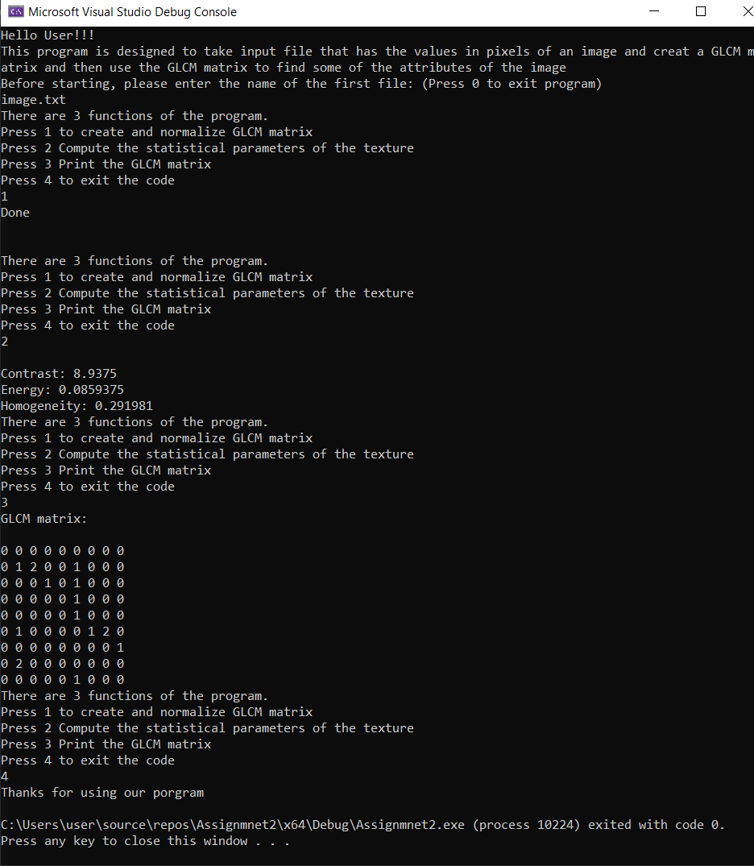2 3 5 7 1

4 5 7 1 2

8 5 1 2 5

**Test #2:**

File: “image.txt”

10 10

1 5 1 5 3 1 3 3 3 2

1 4 0 3 3 1 1 1 3 0

3 4 3 0 1 1 0 2 5 0

2 0 2 1 3 0 1 5 1 1

1 2 4 3 4 4 0 5 2 2

3 2 4 2 3 5 1 1 2 5

1 4 0 5 3 4 4 0 2 1

4 0 0 0 5 4 5 2 3 4

1 3 0 3 2 3 3 0 4 5

1 4 3 2 5 4 5 2 5 1

**Test # 3:**

File: “image.txt”

3 3

1 2 3

9 5 4

6 6 7

**Test #4 :**

File: “image.txt”

3 3

1 2 3

9 5 4

6 6 7

